Unix Command

**Mkdir :** create new directory with given name

e.g. mkdir xyz

**ls:** list the directory and file

blue colour represents directory.

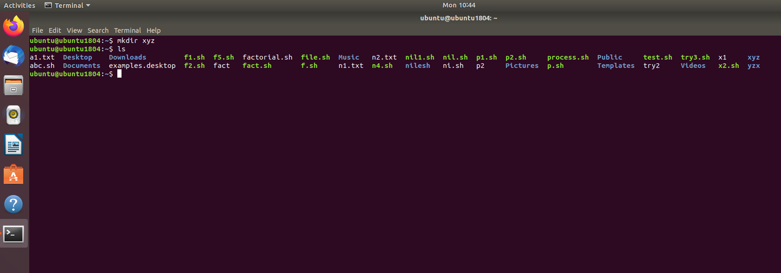

**ls *.txt** : it will display only text files.

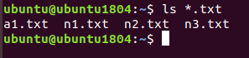

**Cd :** Change directory

e.g. Cd directory name

Cd xyz

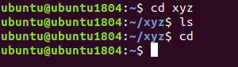

**touch** : to create empty file

e.g. touch file name

touch n1.txt



**cat > filename** : create new file and enter content into the file

e.g. cat>n2.txt enter

enter the content and ctrl D to save the content into the file

cat filename : display the content of the file

e.g. cat n2.txt

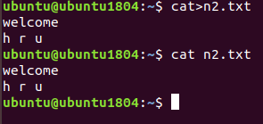

cat>n3.txt

Happy new year ctrlD to save

**cat file1 file2>file3** : create new file and content of both will be copied in new file.

e.g. cat n1.txt n2.txt>cat n3.txt

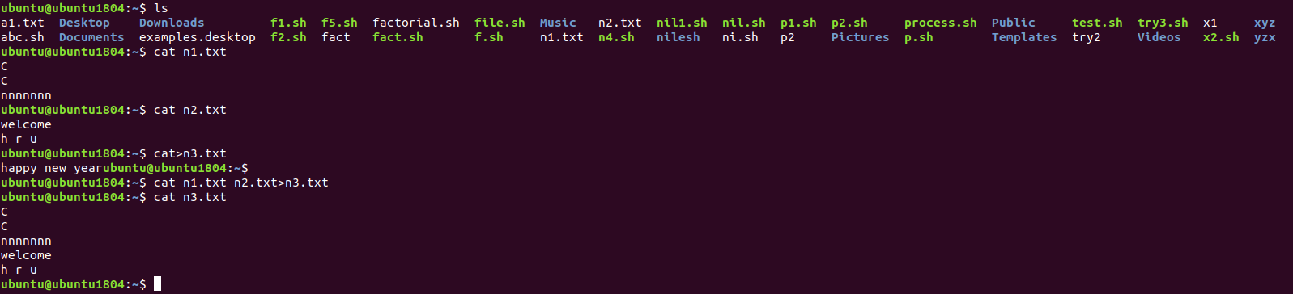

**Pwd:** displays current working directory (present working directory)



**cp:** copy a file or directory

cp file 1.txt file2.txt

e.g. cp n2.txt n4.txt

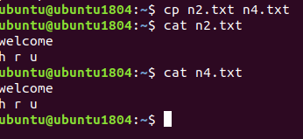

mv : move file or directory

e.g. mv file name location(path)

**head file name:** It will display top ten lines of the file.

e.g. head n1.txt

**tail file name:** It will display last 10 lines of the file.

**more file name**: display large content by using enter or spacebar….similar to cat command

e.g. more n1.txt

**id:** it displays user id or group id



**Clear:** It is used to clear the screen

**Grep:** it is used to search pattern in the file name.

e.g. grep pattern file name

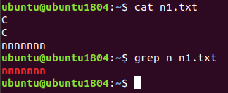

**Ubuntu: $ chmod o+wx n4.txt give the write and execute permission others**

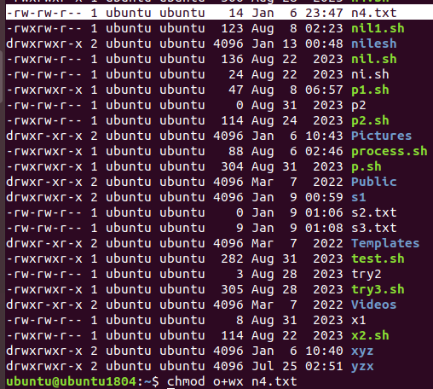

$ ls –l list the file and directories

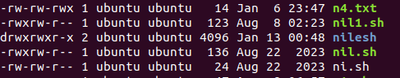

**Ubuntu: $ chmod g+wx n4.txt give the write and execute permission to group**

**Ubuntu: $ chmod a+rwx n4.txt give read, write and execute permission to all**

**Ubuntu: $ chmod o-wx n4.txt remove write and execute permission to other**

**Try it**

**chmod numeric**



**$ chmod 777 s2.txt**



**$ chmod 776 desktop/ desktop is folder name, change the permission of desktop folder**

**ls –lrth**

**ls –l**

**Change Ownership**

**Make a new directory**

**Mkdir new**

**ls -lrth**



**mkdir board**

**#**

**# touch board/board{1..3}.txt**

**# ls –lrth board/**



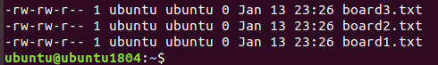

**#touch mfile.txt**

**#ls –lrth**



**#chown –R Nilesh board/ change the ownership of folder board and all files in folder**

**Change ownership using sudo**



**$ ls -lrth**



**Change user and group ownership**

**$ chown nilesh:nilesh mfile.txt**

**$ ls –lrth**

**Change Group**

**$ chgrp nilesh mfile.txt**

**$ sudo chgrp –c n6 n4.txt**



